**Documentation**

**Description of the Project**

* **Introduction:**

Realtime weather and forecast service is an indispensable necessity in a student life. Especially in Ontario winter, students need to know how the weather is today to prevent being blocked by the blizzard. We developed this app, Algonquin College Weather Station, so that students can check the weather conditions on campus, or somewhere at any time on the phone or computer.

In this web application, users could directly check the three Algonquin College campuses weather information and could search by city name to check the weather you want to know. Furthermore, users can create a list including some locations weather information and check it anytime when user opens the default page. Absolutely, the user could edit and remove the list anytime. Nowadays, the dark mode is extremely popular, and it will be available in this application as well. For product improvements, the form could submit suggestions, bugs, or thanks at the end of the application.

Algonquin College Weather Station application will support every student to live and learn here.

* **Key Feature:**
* Based on real time data from weather station around the world​
* Search by any city name, postcode, latitude and longitude for anywhere​
* Location based and watching list for current and forecast​
* Mobile-friendly design and great user experience​
* Local cache data and less network access​
* Open-source project easy to customization and integration​
* Internationalization Support

**Web Map**

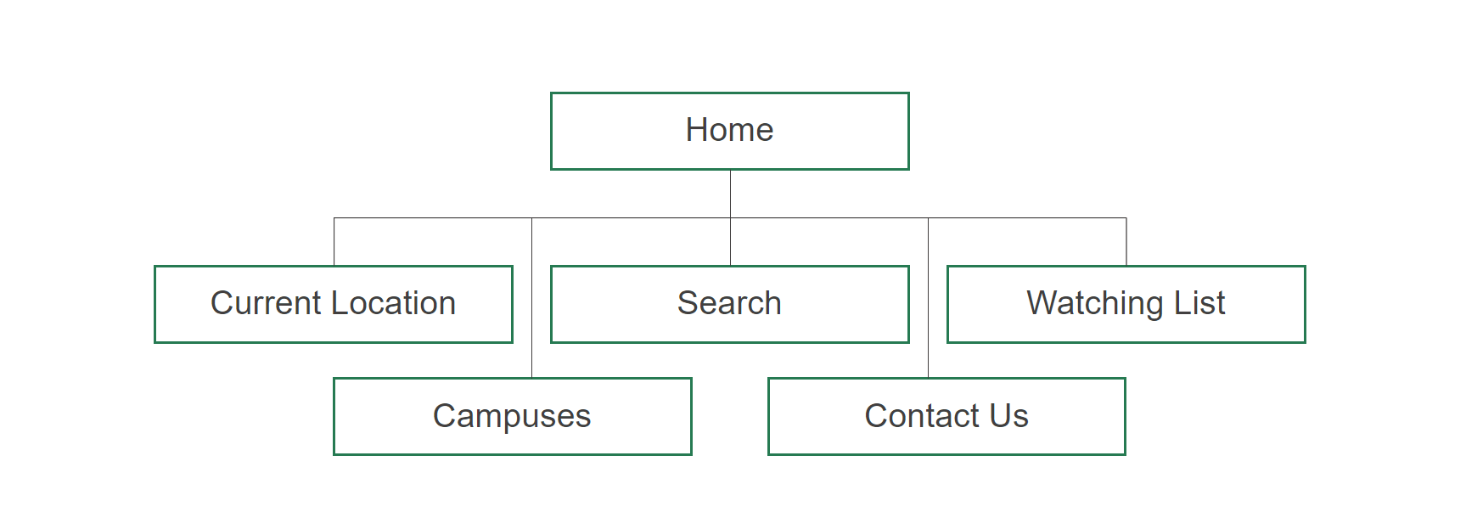

**design guide**

**color schemes:**

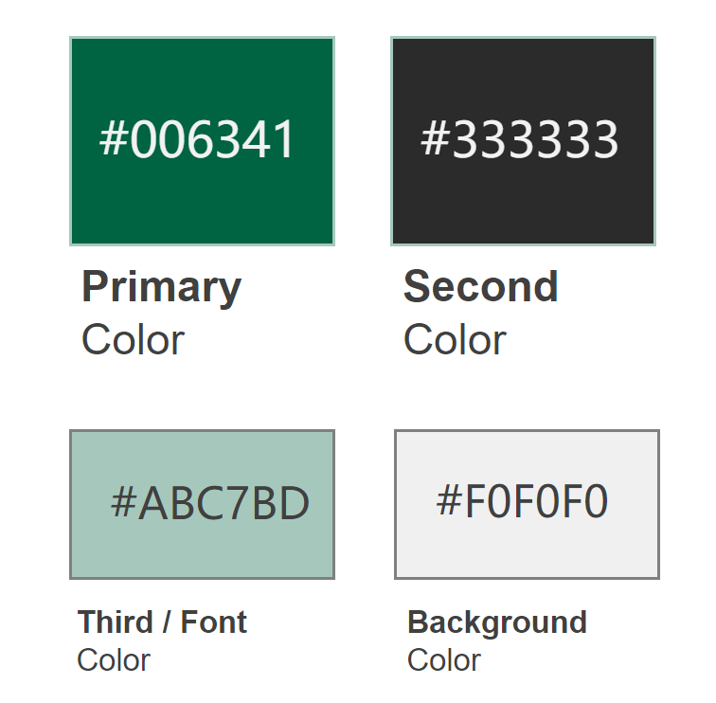

* **Semantic design guide:**

The whole website is divided into three pages: the home page (main page), the contact us page, and the about page. Each page has the same banner logo, header menu, and footer menu.

**<header>:** 

At the top of the page. In <png> tag, include the logo of the website. In <nav> tag, contains <a> tags to identify header navigation, link to home page, contact page and about page.

**<main>:**

**<section>:** Current location campus part.

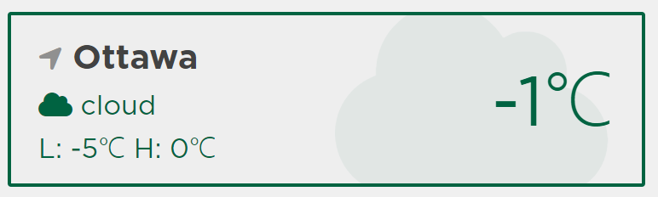

Through the combination of <div>, <li>, <ul>, <i> and <a> tags, to display Ottawa campus weather information card. Showing the city name, current temperature, current weather status, the highest and lowest temperatures of today. Click the weather information card will link to the more specific details weather page.

**<section>:** Search part.



To contain <div> tags that allow users to enter and retrieve weather information by city name, postcode, latitude and longitude.  After searching will link to weather page to show detailed weather information.

**<section>:** All three-campus part.



Same as current campus weather information part, to display Ottawa, Pembroke and Perth campuses weather information cards.

**Contact Us page**

In <form> tag, through the combination of <div>, <label>, <input>, <span>, <select>, <opinion>, <fieldset>,<legend>,<button>, <i> and <textarea> tags to show the contact us form. Each prompt used icons from fontawesome.

**About page**

To introduce Algonquin College Weather Station website in general.

**Weather page**

To specify show detailed weather information including: hourly weather information, feels like temperature, visibility, humidity and windspeed.

**<footer>:**



At the bottom of the page. In <png> tag, include the white version of logo. In <a> tags, to identify footer navigation, link to home page, contact page, about page, GitHub and Trello of our team project. GitHub and Trello used icons from fontawesome.

**user interface functionality guide**

* **modules**

config.js

geocoding.js

weather_cache.js

weather.js

* **pages**

contact_us.js

index.js

weather.js

* **ui**

card.js

current_card.js

search.js

watching_list.js